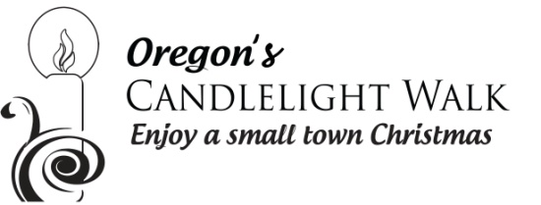
Greetings Business Leaders!
Although the weather doesn’t reflect it now, here comes Christmas! The Oregon Area Chamber of Commerce and its Candlelight Walk Committee are hard at work planning the festivities that kick off the holiday season. Part of that effort includes what we believe to be an important aspect of our community aesthetics – the “look” of the downtown – in design, compatibility and continuity. Over recent years the addition of holiday banners, lovely baskets with greenery and bows, lighted snowflakes, and a beautiful live tree with lighted star atop have added so much to create and enhance our community’s holiday charm. It is our desire to give a warm welcome to those who travel through, and stop to visit, this great community that we call home!
We will continue the efforts initiated six years ago, and hang live White Pine and Cedar Roping with coordinated bows, not only throughout the downtown area, but also at all businesses in outlying areas that want to participate in this team effort to enhance our appearance. We hope that each of you, the businesses who are so important to the look and feel of our downtown and commerce in general, will choose to join our efforts to create an appealing visual to the holiday scene we are working so hard to achieve. This is a project of extreme measure, and there is benefit in this effort for all of us.
For $60 your store will receive garland and coordinating bows, plus the service of hanging these components! Please note - you may order / your space may require more than one roll to adequately drape the space. We will remove and dispose of the materials when the time comes and store (or replace as necessary) the bows properly until next season. A pretty great deal … yes?
Please fill out the small form below, detach and include payment to show your support of your business presence in our community. Our quantity is limited, so please get your order in ASAP! Please make checks payable to the Oregon Area Chamber of Commerce. You can also now pay online with a credit card.
Contact Liz Vos at the Chamber at 815- 732-2100 or chamber.director@oregonil.com with questions!
Coming in Christmas of 2023… Drive through Light Show at Stronghold Castle! Start getting your teams together to build or purchase a sponsored display!
Form and payment needed by October 15th to participate!
----------------------------------------------------------------------------------------------------------------------------------
Business Name: _________________________________________________________________
Business Address: _________________________________________________________________
Contact Person: _________________________________________________________________
Phone Number: _______________________ Email Address: _______________________________
Office Use Only Paid by: Check # ____________ Cash: _____________ Date:_____________
Credit card #, Name on Card, CVV #, Zip Code for card_________________________________________________________________

